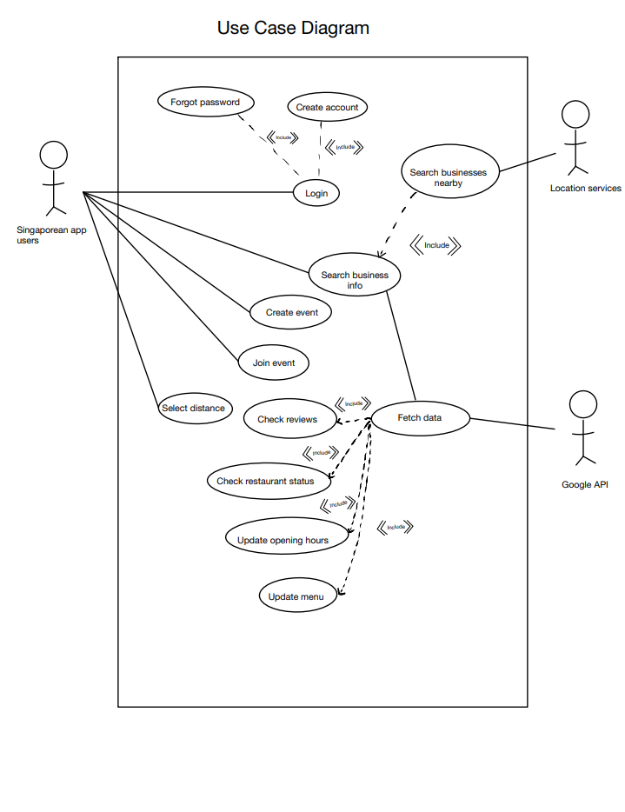

|  |  |  |  |
| --- | --- | --- | --- |
| Use Case ID: | G3001 | | |
| Use Case Name: | Search Business Info | | |
| Created By: |  | Last Updated By: |  |
| Date Created: | 26/8/2022 | Date Last Updated: | 31/8/2022 |

|  |  |
| --- | --- |
| Actor: | Singapore App User |
| Description: | This use case allows users to search for information about any restaurant |
| Preconditions: | User’s device should be connected to the Internet  User can only search based on their current location, if location services is enabled on their device |
| Postconditions: | All restaurant that within the defined location range and filters, that matches the search case will be displayed |
| Priority: | High |
| Frequency of Use: | High, upon user’s request |
| Flow of Events: | 1. The user calls this function by    1. Entering the name, description, or location of their desired restaurant through the search bar       1. Can adjust the filter based on their preference, which affects search results       2. The user clicks on the “Current Location” button in search bar          1. A request access to the user’s location service will be sent 2. All restaurant within the defined location range and filters, that matches the search case will be displayed, with order based on how close it matches the search parameters, and proximity to user’s location (if enabled) |
| Alternative Flows: | G3001 .AC. 1:  Step 1.1.1 – No restaurant can be found based on user’s search parameters   1. A pop-up toast message that shows “No results found” will be displayed 2. (Can consider auto increase radius??) |
| Exceptions: |  |
| Includes: |  |
| Special Requirements: |  |
| Assumptions: | User’s device have enough memory to launch the app  Browser supports our application |
| Notes and Issues: | Ajax application  Debounce/Throttle (increase loading speed) |

|  |  |  |  |
| --- | --- | --- | --- |
| Use Case ID: | G3002 | | |
| Use Case Name: | Create Event | | |
| Created By: |  | Last Updated By: |  |
| Date Created: | 26/8/2022 | Date Last Updated: | 30/8/2022 |

|  |  |
| --- | --- |
| Actor: | User |
| Description: | This use case allows for users to create an event based on a particular Restaurant, such that their friends can join |
| Preconditions: | User’s device should be connected to the Internet  Able to execute G3001: Search business info, and have already successfully searched a restaurant  User have an account and is signed in |
| Postconditions: | An event will be created and displayed to other users |
| Priority: | Medium-Low |
| Frequency of Use: | A few times a week (2-3 times) |
| Flow of Events: | 1. The user should have already searched for a business, and clicked on it for more information 2. User will click on the button “Create Event” 3. User will be prompted for event details    1. Event Name, Visibility, time, duration 4. Event will be |
| Alternative Flows: | GS3002.AC.1:  Step 2 - User is not logged in   1. A dialog box that shows “No results found” will be displayed, with buttons that says “login now” and Cancel    1. If user clicks “login now”       1. They will be re-directed to the login page       2. Once successfully logged in, user will be sent back to step 3 to continue creating the event    2. If user clicks “Cancel”       1. User will be sent back to step 1   GS3002.AC.2:  Step 3 – Time given by user falls outside of Restaurant’s opening hours   1. A dialog box that shows “Time falls outside of operating hours!” will be displayed    1. User will be sent back to Step 3 to adjust the event time |
| Exceptions: |  |
| Includes: |  |
| Special Requirements: |  |
| Assumptions: |  |
| Notes and Issues: | Not a high priority development as not really part of the main function |

|  |  |  |  |
| --- | --- | --- | --- |
| Use Case ID: | G3004 | | |
| Use Case Name: | Join Event | | |
| Created By: |  | Last Updated By: |  |
| Date Created: | 26/8/2022 | Date Last Updated: | 30/8/2022 |

|  |  |
| --- | --- |
| Actor: |  |
| Description: |  |
| Preconditions: |  |
| Postconditions: |  |
| Priority: |  |
| Frequency of Use: |  |
| Flow of Events: |  |
| Alternative Flows: |  |
| Exceptions: |  |
| Includes: |  |
| Special Requirements: |  |
| Assumptions: |  |
| Notes and Issues: |  |

|  |  |  |  |
| --- | --- | --- | --- |
| Use Case ID: | G3005 | | |
| Use Case Name: | Log in | | |
| Created By: |  | Last Updated By: |  |
| Date Created: | 26/8/2022 | Date Last Updated: | 31/8/2022 |

|  |  |
| --- | --- |
| Actor: | User |
| Description: |  |
| Preconditions: | User’s device should have access to Internet  User should have already registered for an account |
| Postconditions: |  |
| Priority: |  |
| Frequency of Use: |  |
| Flow of Events: |  |
| Alternative Flows: |  |
| Exceptions: |  |
| Includes: |  |
| Special Requirements: |  |
| Assumptions: |  |
| Notes and Issues: |  |

|  |  |  |  |
| --- | --- | --- | --- |
| Use Case ID: | G3006 | | |
| Use Case Name: | Register | | |
| Created By: |  | Last Updated By: |  |
| Date Created: | 26/8/2022 | Date Last Updated: | 31/8/2022 |

|  |  |
| --- | --- |
| Actor: | User |
| Description: | Register |
| Preconditions: | User’s device should have access to Internet  User’s email should not be previously registered before |
| Postconditions: |  |
| Priority: |  |
| Frequency of Use: | Once per user |
| Flow of Events: | Create account with email and password  Password must include certain characters  Email and password set in mySQL database / KV store like Cassandra  Salt the password with a hashvalue |
| Alternative Flows: |  |
| Exceptions: |  |
| Includes: |  |
| Special Requirements: |  |
| Assumptions: |  |
| Notes and Issues: |  |